Generated Reports are listed below:Barchart-0-Cat-Status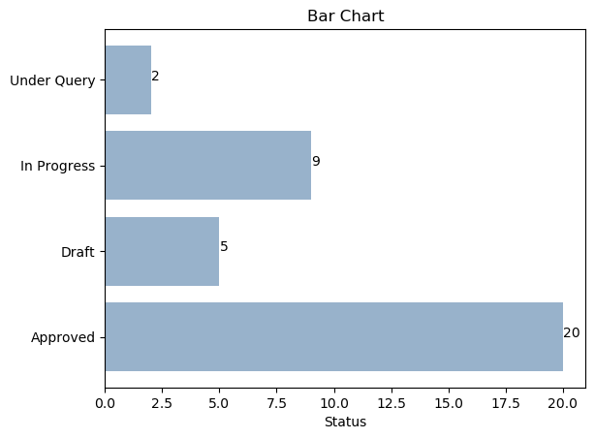Line-plot-chart-3-Cat-Category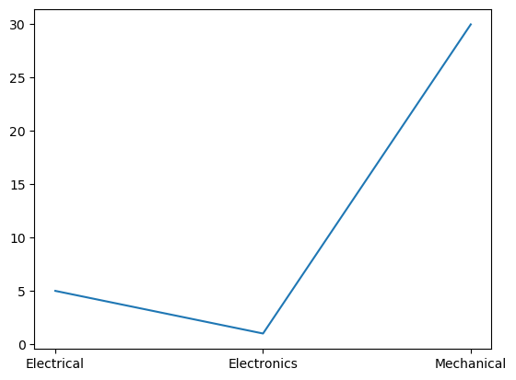Piechart-1-Cat-ApprovedEmpId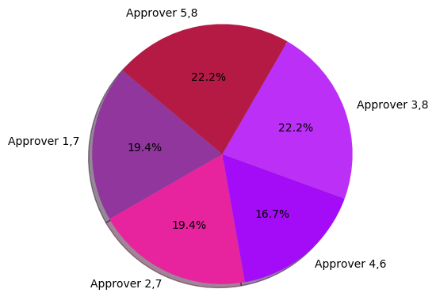Scatter-plot-chart-2-Cat-CreatedEmpId